Name: Date:

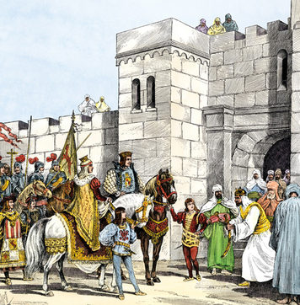
Reading Further - Changes in Europe Spur Exploration

The late 1400s and the early 1500s brought great changes to Europe. One old religious conflict ended. Then a new one began. How did Europe’s conflicts help spur the Age of Exploration?
Walking up the hill, King Ferdinand and Queen Isabella smiled. Before them stood the magnificent palaces of Granada. This elegant city had been a stronghold of Muslim Spain for centuries. Christians had tried to regain control of the land many times. At last, in 1492, Ferdinand and Isabella succeeded. Their armies had defeated the Muslims and retaken Spain. Now the city was theirs. Happily, they accepted the keys to their new home. Boabdil, the Muslim ruler of the city, gave them over with a sigh.
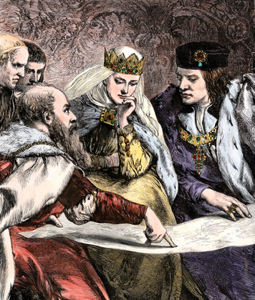
Muslims are people who follow the religion of Islam. The Muslim world began in Southwest Asia. But it quickly spread. In the 700s, the Muslims crossed the Mediterranean Sea. They gained control of the land we now call Spain. The Muslims built a great center of culture and learning in Spain. Much of the rest of Europe, however, followed the Christian religion. Many European Christians were troubled by the Muslim presence. They did not want to allow the practice of other religions in the region. Groups of Christians fought to drive the Muslims out of Spain off and on for centuries. But finally, Isabella and Ferdinand had completed the reconquest of Spain. All the lands of Spain were now under Christian rule.

The Queen Meets Columbus
Not long after taking control, Queen Isabella met a newcomer to her land. He came from Genoa, Italy. His name was Christopher Columbus and he needed her help. Columbus wanted to sail ships west across the Atlantic Ocean in search of a new trade route to Asia. This would help Spain expand its trade in spices and other goods from China and the islands of the East. Columbus also hoped to find and bring back gold and silver. Both the route and the riches could make Spain more powerful. But exploration by sea was still a new idea in 1492. Sailors from the country of Portugal had sailed as far as the coast of Africa. Nobody really knew what lay beyond the Atlantic Ocean.
Many people in Spain did not take Columbus’s ideas seriously. Queen Isabella rejected his plans twice. But the reconquest of Spain had inspired her. She now ruled over a unified, Christian Spain—a great and powerful nation-state. Her victory over the Muslims filled her with deep religious feeling. She was determined to continue to spread her Catholic faith beyond Spain. This was one reason that Columbus’s ideas finally caught her attention.
Queen Isabella met with Columbus. She finally decided that Columbus’ voyage could mean new wealth and a chance to spread Spain’s rule and religion to other lands. Queen Isabella agreed to support Columbus. She and her husband gave him ships and money. Now, Columbus could make the journey to search out new places to claim for Spain. He would seek to bring more people to God—and more power and wealth to Spain. A new age of discovery had begun.

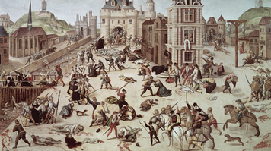
Religious Wars in Europe
Twenty-five years had passed since Christopher Columbus set sail. A man named Martin Luther stood before a Catholic church. In his hands was a document. It included 95 reasons why he questioned the authority of the Catholic Church. Some say that Luther nailed his questions to the church door. Europe—and the world—would never be the same.
In 1517, there was only one type of Christian religion in Europe—the Catholic Church. Luther’s questions challenged this Church. Luther hoped to improve, or reform, the Church. For this reason, he is known as the founder of a movement called the Reformation. Luther’s actions started a great conflict. Catholic Church leaders rejected his complaints. But many people agreed with Luther. Some of them left the Catholic Church. They formed new churches and became known as Protestants. The term Protestant comes from the word protest.
The Reformation divided Europe. At that time, people did not easily accept religious differences. Catholic leaders launched a movement called the Counter Reformation. The word counter means “against.” Kings and queens waged war with one another over religion. Many people were forced to follow their rulers’ beliefs. Europe in the 1500s became a bloody battleground. Thousands died in religious wars.

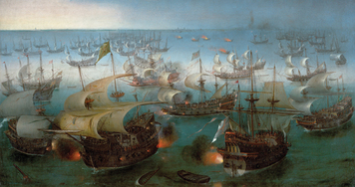
Conflict Between England and Spain

Tensions between England and Spain had been high for many years. One major reason was religion. In the 1530s, England’s King Henry VIII had broken with the Catholic Church. As a Protestant country, England found that it had new enemies. Among them were Spain’s Catholic rulers, who were deeply religious.
Queen Elizabeth I came to power in England in 1558. She spent much of her reign in disputes with Spain. For a time, Queen Elizabeth helped pirates who preyed on Spanish ships in the English Channel. She also assisted Protestants who fought against Spanish rule. Meanwhile, the Spanish king supported plots against Queen Elizabeth.
The conflict reached a peak in 1588. Spain had assembled a huge fleet of warships. This Spanish Armada was one of the most powerful forces ever gathered. Its 130 ships carried 30 thousand sailors and bristled with guns. When it set sail for England, the future looked dark for Queen Elizabeth and her country. But the English navy fought fiercely against the Spanish. In one of history’s greatest naval battles, the English navy defeated the Spanish Armada. However, Spain’s power remained a threat. England had been slower than many other European nations to explore overseas. Queen Elizabeth now chose a new course. England, too, would seek wealth and power across the ocean. The conflicts and rivalries among the nations of Europe would spread to the Americas. These struggles would spur exploration and settlement.

